Internal Assessment Resource
Agricultural and Horticultural Science Level 1
EXPIRED
This resource supports assessment against:
Achievement Standard 90920 version 2
Demonstrate knowledge of the geographic distribution of agricultural and horticultural primary production in New Zealand
Resource title: Wherever, why ever?
3 credits
This resource:
- Clarifies the requirements of the standard
- Supports good assessment practice
- Should be subjected to the school’s usual assessment quality assurance process
- Should be modified to make the context relevant to students in their school environment and ensure that submitted evidence is authentic

Date version published by Ministry of Education | February 2015 Version 3  To support internal assessment from 2015
Quality assurance status | These materials have been quality assured by NZQA.  NZQA Approved number A-A-02-2015-90920-02-4360
Authenticity of evidence | Teachers must manage authenticity for any assessment from a public source, because students may have access to the assessment schedule or student exemplar material.  Using this assessment resource without modification may mean that students’ work is not authentic. The teacher may need to change figures, measurements or data sources or set a different context or topic to be investigated or a different text to read or perform.

Internal Assessment Resource
Achievement Standard Agricultural and Horticultural Science 90920: Demonstrate knowledge of the geographic distribution of agricultural and horticultural primary production in New Zealand
Resource reference: Agricultural and Horticultural Science 1.4A v3
Resource title: Wherever, why ever?
Credits: 3
Teacher guidelines
The following guidelines are supplied to enable teachers to carry out valid and consistent assessment using this internal assessment resource.
Teachers need to be very familiar with the outcome being assessed by Achievement Standard Agricultural and Horticultural Science 90920. The achievement criteria and the explanatory notes contain information, definitions, and requirements that are crucial when interpreting the standard and assessing students against it.
Context/setting
This activity requires students to demonstrate in written form their knowledge of the geographic distribution of three types of agricultural or horticultural primary production in New Zealand. Students must include at least one example of agricultural primary production and one example of horticultural primary production in their response to the text.
Conditions
This is an individual assessment activity. Students will complete the assessment during class time. Adapt the time allowed in the student instructions to meet the needs of your students.
Resource requirements
Copies of Resources A, B, C, and D for each student.
Additional information
None

Internal Assessment Resource
Achievement Standard Agricultural and Horticultural Science 90920: Demonstrate knowledge of the geographic distribution of agricultural and horticultural primary production in New Zealand
Resource reference: Agricultural and Horticultural Science 1.4A v3
Resource title: Wherever, why ever?
Credits: 3
Achievement | Achievement with Merit | Achievement with Excellence
Demonstrate knowledge of the geographic distribution of agricultural and horticultural primary production in New Zealand. | Demonstrate detailed knowledge of the geographic distribution of agricultural and horticultural primary production in New Zealand. | Demonstrate comprehensive knowledge of the geographic distribution of agricultural and horticultural primary production in New Zealand.
Student instructions
Introduction
This assessment activity requires you to identify the geographic distribution of three types of agricultural or horticultural primary production in New Zealand and explain the factors that influence their distribution.
This is an individual assessment activity.
You have <<XX>> of in- and/or out-of-class time to complete this activity.
You will be assessed on how well you are able to describe and explain the geographic distribution.
Teacher note: Adapt the student instructions to meet the needs of your students.
Task
Choose three types of primary production from the lists below. Include at least one from list A and one from list B, plus one other.
A: Agricultural primary production | B: Horticultural primary production
- Arable crops (such as wheat)  - Dairying  - Deer  - Extensive sheep and beef  - Semi-intensive sheep and beef  - Fine wool  - Forestry  - Another agricultural product agreed with your teacher | - Berries (such as strawberries)  - Cut flowers  - Citrus fruit (such as oranges)  - Grapes  - Kiwifruit  - Market gardens  - Pip fruit (such as apples)  - Another horticultural product agreed with your teacher
For each type of primary production:
Identify at least two key regions in New Zealand where this type of primary production is carried out.
Describe the factors that the key regions have in common that contribute to successful production. Not all factors will be common to all regions.
Make sure you describe factors from at least two of the following groups so that you can compare and contrast the effect:
- physical factors (for example, topography and soil)
- climatic factors (for example, rainfall, temperature, and sunshine)
- market factors (for example, transport and the location of ports, processing plants, and population centres).
Explain how the factors you have described influence the geographic distribution of this primary production.
Use your understanding of the specific factors to determine whether one group of factors has a greater effect than another group of factors on geographic distribution.
Compare and/or contrast the effect that each group has on the geographical distribution.
Student resources
Resource A: Regions of New Zealand
Names of Regions  - Northland  - Auckland  - Waikato  - Bay of Plenty  - Gisborne / East Coast  - Hawke’s Bay  - Taranaki  - Whanganui  - Manawatu  - Wairarapa  - Wellington  - Nelson & Bays  - Marlborough  - West Coast  - Canterbury  - South Canterbury / North Otago  - Otago  - Southland | 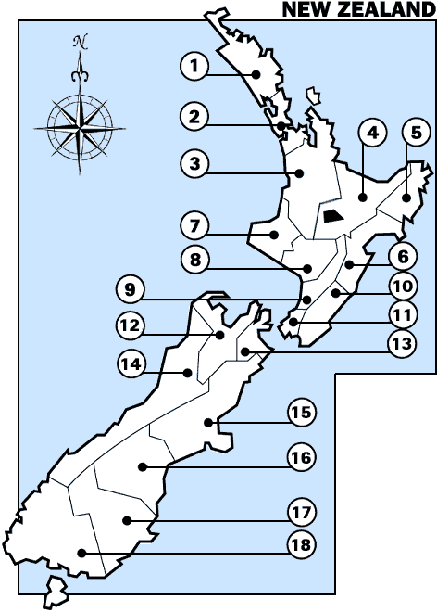  [Source: http://www.yellowpages.co.nz/maps/]

Resource B: Climate information
REGION | MEAN ANNUAL |  |  | Temperature |  | Number of days with frosts
REGION | Rainfall (mm) | Sunshine (hours) | Temperature (°C) |  |  | Number of days with frosts
 |  |  |  | Very highest (°C) | Very lowest (°C) | Number of days with frosts
Northland | 1412 | 2021 | 15.6 | 30.8 | -0.1 | 5
Auckland | 1240 | 2060 | 15.1 | 30.5 | -2.5 | 10
Bay of Plenty | 1198 | 2260 | 14.5 | 33.7 | -5.3 | 42
Waikato | 1190 | 2009 | 13.7 | 34.7 | -9.9 | 63
Gisborne | 1051 | 2180 | 14.3 | 38.1 | -5.3 | 33
Taranaki | 1432 | 2182 | 13.7 | 30.3 | -2.4 | 15
Hawkes Bay | 803 | 2188 | 14.5 | 35.8 | -3.9 | 29
Whanganui | 882 | 2043 | 14.0 | 32.3 | -2.3 | 7
Manawatu | 967 | 1733 | 13.3 | 33.0 | -6.0 | 38
Wairarapa | 979 | 1915 | 12.7 | 35.2 | -6.9 | 60
Wellington | 1249 | 2065 | 12.8 | 31.1 | -1.9 | 10
Nelson | 970 | 2405 | 12.6 | 36.3 | -6.6 | 88
Marlborough | 655 | 2409 | 12.9 | 36.0 | -8.8 | 60
West Coast | 2875 | 1860 | 11.7 | 30.0 | -3.4 | 54
Canterbury | 648 | 2100 | 12.1 | 41.6 | -7.1 | 70
South Canterbury / North Otago | 573 | 1826 | 11.2 | 37.2 | -6.8 | 84
Otago | 812 | 1585 | 11.0 | 35.7 | -8.0 | 58
Southland | 1112 | 1614 | 9.9 | 32.2 | -9.0 | 94

[Source: http://www.niwa.co.nz/education-and-training/schools/resources/climate]
Resource C: New Zealand topography
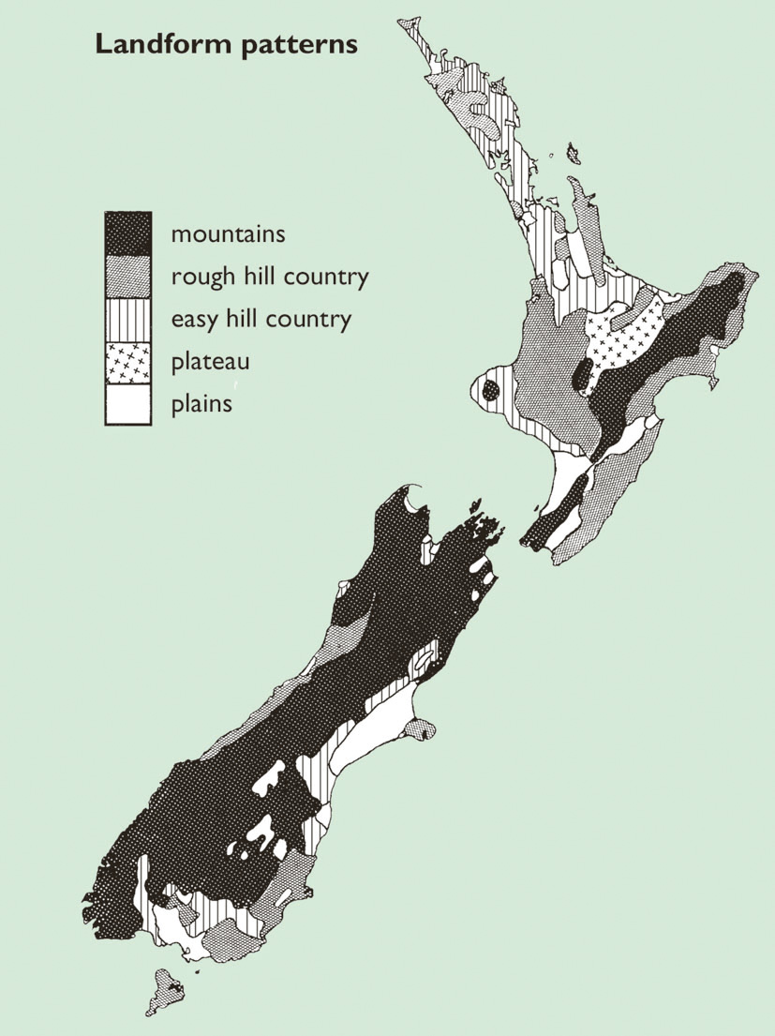

Resource D: Sea ports and airports

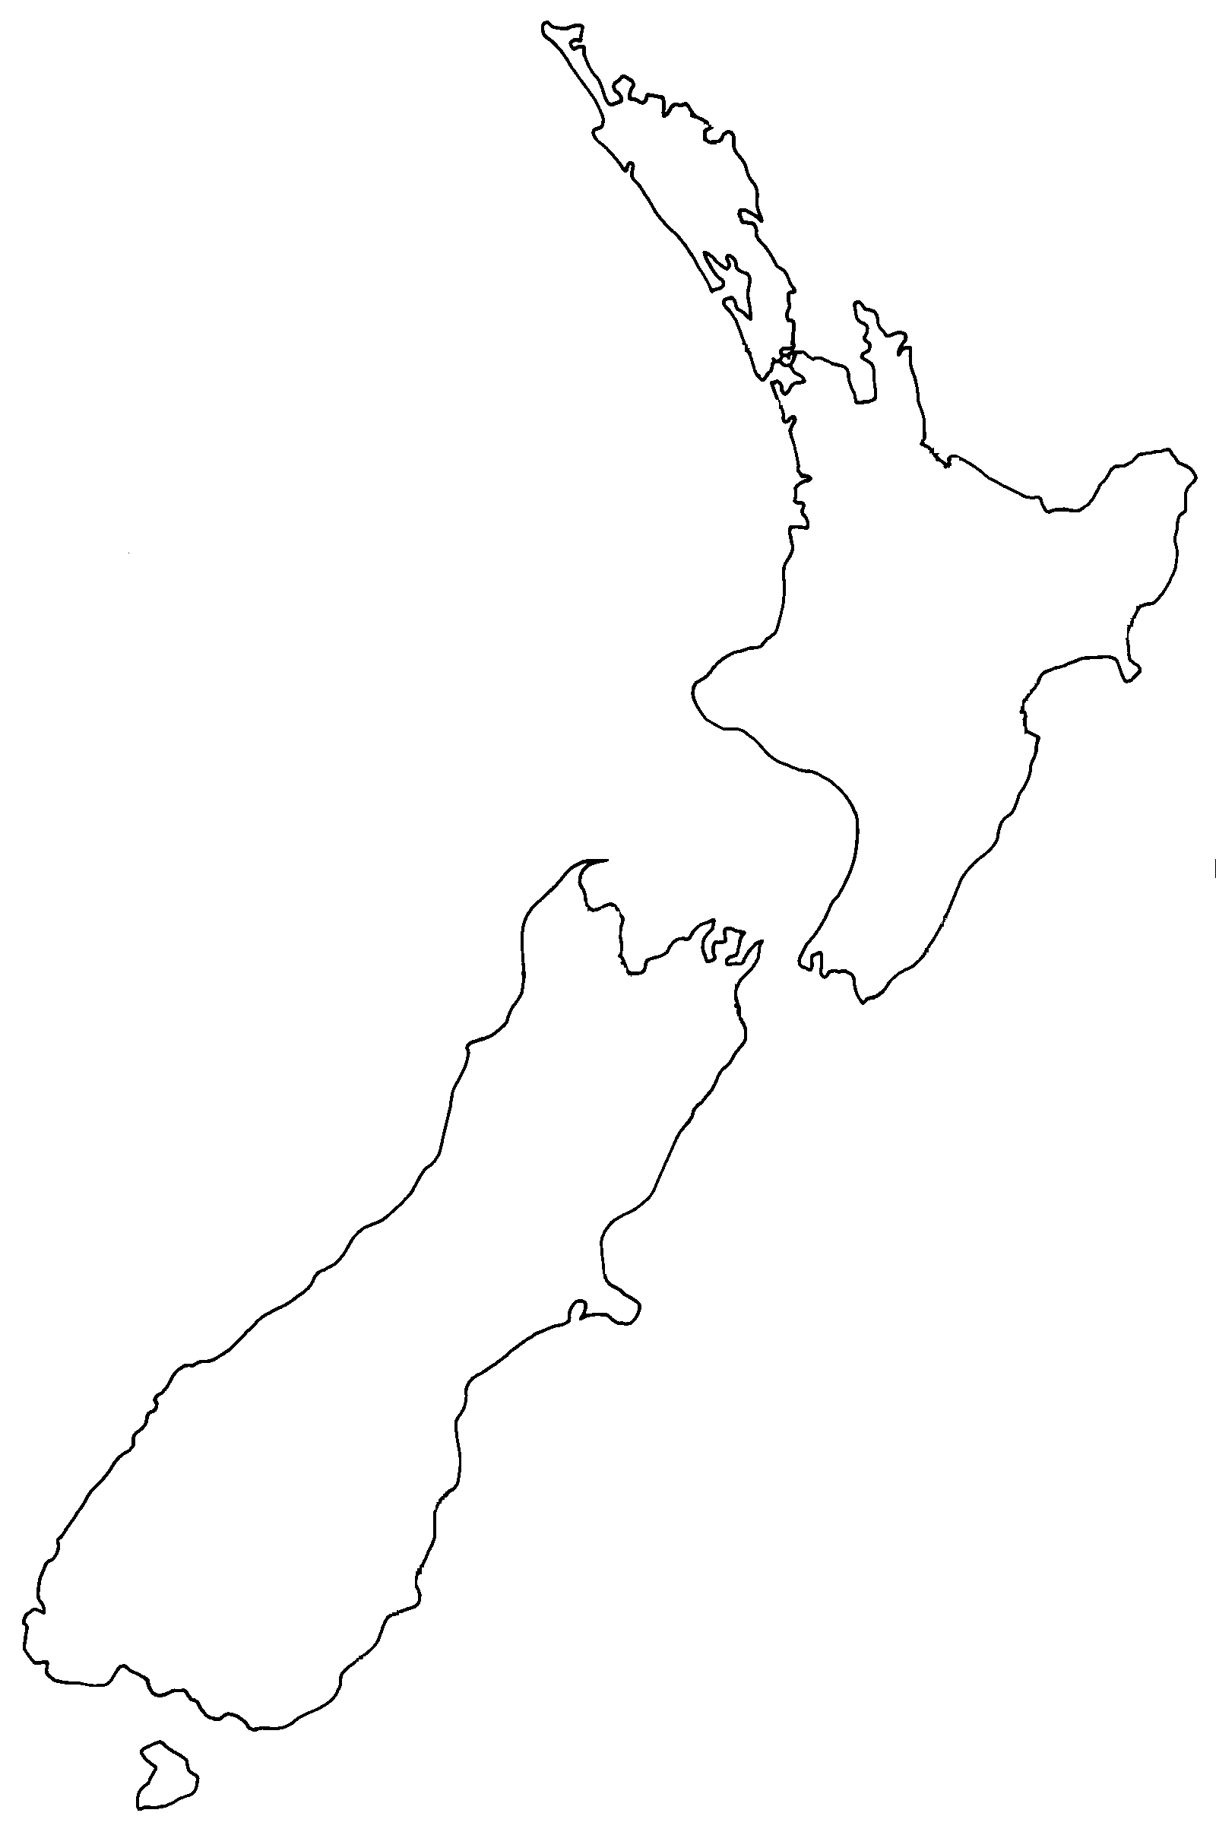
International airport

Sea port

International airport
Assessment schedule: Agricultural and Horticultural Science 90920 Wherever, why ever?
Evidence/Judgements for Achievement | Evidence/Judgements for Achievement with Merit | Evidence/Judgements for Achievement with Excellence
The student demonstrates knowledge by identifying the geographic distribution of three types of primary production and describing the factors responsible for this distribution in New Zealand.  The student presents at least one type of agricultural and one type of horticultural production.  The student describes at least two factors (physical, climatic, and/or market factors).  For example, a student could give the following information about dairying:  Regions: Waikato, Taranaki, Southland, Canterbury  Physical factors: The land in these regions where dairying occurs is relatively flat.  Climatic factors: In most of these regions there is plenty of rain. (Canterbury is the exception but there is a lot of irrigation there.)  Market factors: The processing plants tend to be located close to the major dairying areas in these regions. | The student demonstrates detailed knowledge by identifying the geographic distribution of three types of primary production and explaining the factors responsible for this distribution in New Zealand.  The student presents at least one type of agricultural and one type of horticultural production.  The student describes and explains at least two factors (physical, climatic, and/or market factors).  For example, a student could give the following information about dairying:  Regions: Waikato, Taranaki, Southland, Canterbury  Physical factors: The topography in these regions where dairying occurs is relatively flat to rolling land. Cows can waste energy due to movement over steeper country and paddocks must be sown for quality feed supply – flat land allows for tractor work and easier cow movement. The soil types are quite varied from free-draining soils in Taranaki and Canterbury to heavier soils in Waikato and Southland. This impacts on the level of irrigation required to maintain pasture growth.  Climatic factors: In most of these regions, there is an average of 1200mm of annual rainfall. (Canterbury’s 640mm is the exception. However, irrigation has overcome this deficit.) Reliable rainfall and above average temperatures favour all year round pasture growth.  Market factors: The processing plants tend to be located close to the major dairying areas in these regions. They are built in response to dairy production levels while labour to milk cows is normally not a problem. | The student demonstrates comprehensive knowledge by identifying the geographic distribution of three types of primary production, explaining in detail the factors responsible for this distribution in New Zealand, and outlining the relevant importance of those factors for each type of primary production.  The student presents at least one type of agricultural and one type of horticultural production.  The student explains the relative importance of at least two factors (physical, climatic, and/or market factors) on the geographical distribution of dairying.  For example, a student could give the following information on the relative importance of factors on the geographic distribution of dairying:  Regions: Waikato, Taranaki, Southland, Canterbury  Dairying involves converting pasture into milk therefore the most important factors are climatic factors especially rainfall and temperature throughout the year. This allows for good all year round pasture growth needed for high milk production. Cows need a lot of grass to eat if they are to produce enough milk. It is cheaper and easier to graze cows on pasture rather than supply supplementary feeds. Water can be applied by irrigation but there is an expense in doing so while temperature cannot be altered or supplied by the farmer – it must exist in the key regions. In most of these regions, there is an average of 1200mm of annual rainfall. (Canterbury’s 640mm is the exception. However, irrigation has overcome this deficit.)  Dairying requires fertile soils for pasture growth but deficiencies in the soil can be overcome by management such as drainage and fertiliser application and as a result the key regions can differ in soil types. Cows enter the milking shed twice per day therefore short trips over flat to rolling country reduces the amount of energy spent on walking and more energy is available for milk production.  Market factors such as processing plants do not determine where dairying is carried out. Processing plants are established once dairying is established.
Final grades will be decided using professional judgement based on a holistic examination of the evidence provided against the criteria in the Achievement Standard.

